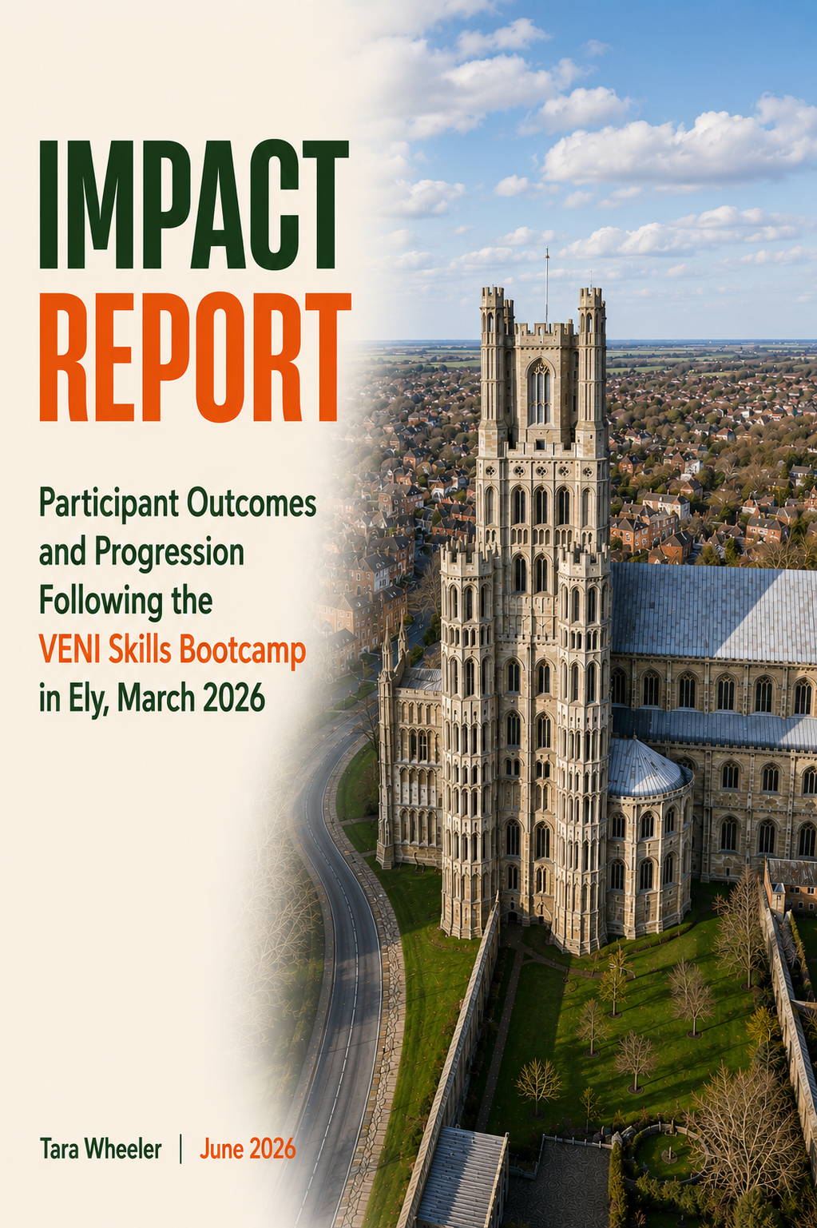

Impact Report for the VENI Skills Bootcamp in Ely, March 2026
"It made me re-evaluate what I think I can do and what I'm capable of."
The VENI Skills Bootcamp was delivered in Ely between February and March 2026 as a 12-day programme designed to prepare participants for employment within the visitor economy. The course combined industry-recognised WorldHost customer service training with practical employability support, including CV development, interview preparation, employer interviews, local ambassador activities and opportunities to learn more about the visitor economy and employment opportunities across the local area.
Participants took part in visits to local businesses and attractions, including Ely Cathedral and other visitor economy organisations, alongside sessions focused on customer service, sustainability, employability and career planning. The programme also explored practical barriers to employment, including transport and mobility challenges, through the Kickstart mobility scheme and discussions about local employment, training and support opportunities.
Twelve participants took part in the programme. Follow-up interviews were conducted in May and June 2026, two to three months after programme completion.
Many participants in this group were starting from a considerable distance from the labour market and described a range of personal, practical and educational barriers to employment. These included long-term health conditions, learning needs, confidence challenges, limited recent work experience and transport barriers.
Given the relatively short period between programme completion and follow-up, employment outcomes should be interpreted cautiously and considered alongside wider evidence of progression and distance travelled. Findings demonstrate positive outcomes in confidence, interview readiness, career ambition and engagement with job search activity across the participant group.
All quotes in orange are from participants and names have been changed.
Key Outcomes
"That really gave my confidence a big boost."
- Twelve participants took part in the programme.
- Three participants have so far found work since the course
- Attendance and retention were strong across the 12-day programme, with overall attendance of 90%.
- Five of the twelve participants attended every session and most attended the majority of delivery days.
- Participants consistently reported increased confidence, particularly in relation to interviews and job applications.
- Several participants described applying for a wider range of roles following the programme, including hospitality, retail, care and catering positions.
- Participants reported increased awareness of local visitor economy opportunities and a broader understanding of how their existing skills could transfer into different roles.
- Multiple participants had attended interviews following the programme and described using techniques learned during delivery.
- Participants reported increased awareness of local employment, training and progression opportunities.
- Participants described increased motivation, career ambition and willingness to explore new opportunities.
- Several participants expressed interest in progressing into further qualifications and training, including catering, digital skills and vocational pathways.
Confidence, Employability and Mindset Shifts
“To be honest, this is going to sound completely not me. I was absolutely bricking it from the start when we had to do the film, but I actually really enjoyed doing that and I ended up helping other people with it!”
A clear theme across interviews was the extent to which the programme improved participants' confidence and interview readiness.
Several participants described entering the programme with low confidence following periods out of work, health challenges or previous negative experiences of employment. Participants frequently reflected on practical techniques learned during the course and how these had helped them approach interviews more positively.
"It definitely boosted my confidence for interviews afterwards. It gave me a few more things to bring up in interviews and some really good questions to ask employers."
For some, the impact extended beyond interviews and led to wider changes in how they viewed their own abilities and future career options.
Participants also described broadening their job search activity following the programme. Others reported applying for hospitality, catering and visitor economy roles they had not previously considered.
"I've definitely seen more roles that I've applied for since doing the course because I didn't look at some hospitality roles before."
Across interviews, participants consistently linked the programme to increased confidence, greater optimism and a stronger belief that employment was achievable.
Understanding the Local Visitor Economy
"One of the most fun parts was walking around Ely, visiting different places and talking to people about the history of Ely and the businesses there."
Participants frequently highlighted local visits, employer engagement and opportunities to learn more about Ely and its visitor economy as particular strengths of the programme.
Visits to Ely Cathedral, local businesses and visitor attractions were mentioned as memorable and engaging experiences. Participants valued learning about the history, culture and employment opportunities available within the local area.
Several participants reported that the programme had increased their awareness of visitor economy careers and helped them understand the breadth of opportunities available within the sector.
"It gave me some different outlooks on how companies work and what to look for."
Participants also described gaining a broader understanding of local opportunities and feeling more confident about engaging with employers and organisations within the area.
Participant Experience of the Programme
Participants consistently described the programme as supportive, engaging and different from other forms of employability provision.
“The sandwiches were fantastic, I miss those sandwiches!”
The combination of practical learning, local visits, employer engagement and group-based activities was particularly well received. Participants valued the opportunity to learn alongside others, share experiences and develop confidence within a supportive environment.
"I 100% recommend that course."
Several participants commented positively on the balance between structured learning and interactive activities, particularly the filming project, employer interviews and local visits.
Participants also appreciated the supportive approach taken by delivery staff and the way the programme encouraged them to recognise existing strengths and transferable skills.
Case Study 1: Karen
Participant names have been changed to protect anonymity.
Karen joined the programme after recently becoming unemployed and initially focused her job search almost entirely on retail positions. At the time, she was experiencing low confidence and uncertainty about her future career direction.
“I think it came at the right time when I needed it because I mean, I was at a real low”
During the programme, Karen developed greater confidence in interviews and learned new techniques that she has gone on to use in interviews, one for a job for which she got through to interview but lost out on because she can’t drive. Karen hadn’t felt able to use eye contact before in interviews:
“I did another technique which is to sit on my hands because I don't never know what to do with my hands. I sat on my hands I looked above their eye like they said to do and I've had nothing but like ‘you've got very good eye contact’ and I'm thinking you don't realise how hard this is to do.”
The programme also encouraged Karen to broaden her thinking about employment opportunities. Following the course, she began exploring care-related roles and other career pathways she had not previously considered.
"Before, all I was doing was looking at retail, retail, retail. Now I'm trying to look at different options."
Reflecting on the experience, she explained:
"It made me re-evaluate what I think I can do and what I'm capable of."
Karen's experience demonstrates how the programme can help participants build confidence, recognise transferable skills and approach new opportunities with greater optimism.
Case Study 2: Anne
Participant names have been changed to protect anonymity.
Anne joined the programme with a strong interest in catering and hospitality and was keen to strengthen her employability skills while exploring future opportunities.
Following the programme, Anne reported applying for catering assistant and kitchen assistant positions and engaging with additional employment support services.
"I have applied for more jobs, which is in my lines of catering assistant and kitchen assistant."
She also described increased confidence when attending interviews and felt the programme had helped move her closer towards her employment goals.
One of them was talking about the interviews and speaking up. That really gave my confidence a big boost."
Anne felt the programme had provided useful information about local opportunities and helped her think more positively about future employment.
Looking ahead, Anne expressed interest in progressing to a Level 2 Food Hygiene qualification and felt that clear progression routes into further training would strengthen future delivery.
Anne's experience highlights the role the programme can play in building confidence, supporting active job search and encouraging progression towards future qualifications and employment.

Conclusions
Evidence gathered through participant interviews suggests the VENI Skills Bootcamp is generating positive progression outcomes, alongside increased confidence, broader career ambition and greater awareness of local employment opportunities.
Many participants were starting from a considerable distance from the labour market and described a range of personal, practical and educational barriers to employment. Given the relatively short follow-up period, employment outcomes should be interpreted cautiously and considered alongside wider evidence of progression and distance travelled.
Attendance and retention were also strong. Twelve participants took part in the programme and overall attendance reached 90% across the 12-day delivery period. Five participants attended every session and most attended the majority of delivery days, indicating sustained engagement throughout the programme.
The programme appears particularly effective because it combines:
- Industry-recognised WorldHost customer service training
- Practical employability support
- Local visitor economy awareness and employer engagement
- Employer interviews and real-world learning experiences
- Confidence building and interview preparation
- Supportive group-based delivery
Importantly, participants reported benefits beyond immediate employment outcomes. The programme has helped individuals build confidence, recognise transferable skills and develop a broader understanding of the opportunities available within the local visitor economy and related sectors. Participants also described increased awareness of further training, employment support and progression opportunities available locally.
Overall, findings suggest the VENI Skills Bootcamp is supporting participants towards employment and progression, while also fostering greater confidence, aspiration and positive engagement with the labour market.
"I've noticed I've become more confident and stuff like that."

